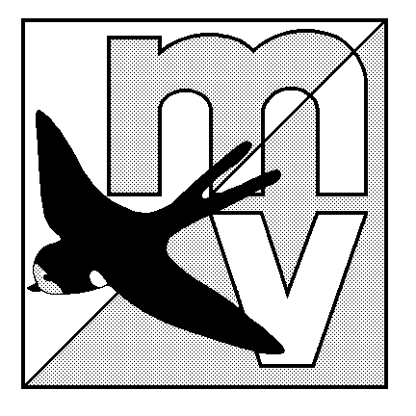
MOLE VALLEY ORIENTEERING CLUB
(Affiliated to the British Orienteering Federation)

LIMITED DISTRICT EVENT
The Nower, Dorking
Monday 29th May 2006
(In conjunction with The 29th Surrey Hill Races)

Venue Small but interesting area of mostly runnable woodland, with many paths. All facilities are close together, and there is an ideal grassy area to have a picnic on after your run!

Car Park The Powell Corderoy School, Dorking, Surrey. OS Map 187, at GR 157487.
Follow ‘Hill Race’ signs from South end of Dorking one-way system.

Map 1:5000, 5m contours

Registration 10.00 - 12.00 Entry on the day only.

Starts 10.30 - 12.30 Courses close 14:30

Courses & Yellow, Orange and Green only. The event will be using SportIdent electronic
Punching punching (hire charge £1).

Fees Seniors £4.00. Juniors £1.50.

Facilities Squash, dogs welcome. Toilets available in Dorking town centre, go before you come please!

Officials Organiser: Neil Lewer
Planner: Simon Ling

MV Web Site http://www.mvoc.org/

Safety Whistles recommended.

Competitors participate at this event at their own risk

